Instructor: Dr. Jie Shen
Release date: Jan. 25, 2021
Due date: Feb. 5, 2021

Student Name: Demetrius Johnson
*Special note: see my lab uploads of the .CPP and .EXE files for ease of access and testing any of the programs for any question.

Table of Contents
Question 1 (2.5 points) 3
Source code (USED C++ COMPILER) 3
Test data and expected results 5
Question 2 (2.5 points) 7
Source code (USED C++ COMPILER) 7
Test data and expected results 9
Question 3 (2.5 points) 11
Source code (USED C++ COMPILER) 11
Test data and expected results 12
Question 4 (2.5 points) 13
Source code (USED C++ COMPILER) 13
Test data and expected results 15
Submission 16
Provide the following: 16
Source code (identify which compiler you used) 16
Test data and expected results 16
Running log/output (screen shots should be provided) 16

Question 1 (2.5 points)

Source code (USED C++ COMPILER)

// CIS 200 - LAB 2 - WINTER 2021 - DEMETRIUS JOHNSON.cpp : This file contains the 'main' function. Program execution begins and ends there.
//

/*
//Author: Demetrius E Johnson
//Date: 4 FEB 2021
//Last Modification Date: 2-5-2021
//Purpose: a program to print an upside-down triangle composed of a symbol provided by user input

*/

/*
//Write a program to print an upside-down triangle composed of a symbol.
//The number of lines in the triangle and the symbol should be entered as input from the keyboard.
//For example, if the input values are 4 and $, the output is as follows:

$$$$$$$
$ $
$ $
$

//In your program documentation, describe the loop(s) used as count-controlled or event-controlled. You should print out the following results:
//(1) 5 and * (five layers and symbol is *)
//(2) 6 and & (six layers and symbol is &)

*/

#include <iostream>
#include <iomanip>
using namespace std;

int main()
{

int userChoice_numLines = 0; //used to store user choice of number of lines in the pyramid
int odd_Character_Count = 0; //use this to make sure that the first line of the triangle will always be an odd number of characters
char userChoice_char = ' '; //used to store the character of the user choice
char empty_Space = ' '; //used to format the triangle with empty spaces on each line as necessary
int space_Counter = 5; //used to control while loop that outputs spaces on a line //initiate it at 5 so it can be positioned slightly to the right
int row_Counter = 0; //used to control which row is being worked on
int char_Counter = 0; //used to control character outputs on a line

//cout << userChoice_char; //used for testing ASCII values
//system("pause");

cout << "------------WELCOME TO THE Triangle Output Program-------------By Demetrius Johnson--------------\n\n";
cout << "This program prints an upside-down triangle composed of a symbol and layer(row) size provided by user input.\n\n";
cout << "Input a character (including a single-digit number) for which the output triangle will be composed of: ";
cin >> userChoice_char;
cout << "Input a number value for the number of layers (rows) the output triangle will be composed of: ";
cin >> userChoice_numLines;
cout << "\n~User Selections for the triangle are --> Character: " << userChoice_char << " Number Of Rows/layers: " << userChoice_numLines << endl << endl;

odd_Character_Count = (userChoice_numLines * 2) - 1; //set the number of char on one line to be double user choice of number of lines; with the first line having an odd number of char on it

row_Counter = userChoice_numLines; //I will always keep userChoice_numLines variable constant so as to always have a reference point for all of my other variables of what the user input for rows
//space_Counter = userChoice_numLines;
while (row_Counter > 0) { //this loop controls a given row of the triangle (i.e. controls which row will be worked on)

for (int i = space_Counter; i > 0; i--){ cout << empty_Space; } //control number of empty spaces on each row
space_Counter++; //increment this variable so that during the next loop the number of initial spaces on the triangle row increases by 1 more than the previous row

char_Counter = odd_Character_Count;
while (char_Counter > 0) { //this loop controls the contents on a given row (i.e. number of characters in a row, including empty spaces)

if (row_Counter == userChoice_numLines) { cout << userChoice_char; } // this statement only executed once for the entire program;
//it is used so that only the first row of the triangle is full of characters

else if (char_Counter == odd_Character_Count || char_Counter == 1) { cout << userChoice_char; } //use this loop for subsequent triangle lines;
//this will ensure the user char is output on the current row
//only at the start and end of the row
else { cout << empty_Space; } //otherwise; input an empty space at the current position on the row

char_Counter--;
}

odd_Character_Count -= 2; //decrement the odd character counter so next row of triangle will have 2 less characters
cout << endl; //move to next row
row_Counter--; //decrement number of rows left to be written
}

cout << endl << "...The Program has finished, user Triangle output successfully; thank you, goodbye...(;\n\n";
system("pause");

return 0;

}

Test data and expected results

Test Table:
Test # | Valid / Invalid Data | Description of test | Input Value | Expected Output | Actual Output | Test Pass / Fail
1 | valid | Test to see if triangle output is accurate | UserChar = *  Number of rows = 5 | Upside down Triangle with 5 rows composed of * | See screenshot | pass
2 | valid | Test to see if triangle output is accurate | UserChar = &  Number of rows = 6 | Upside down Triangle with 6 rows composed of & | See screenshot | pass
3 | valid | Test to see if triangle output is accurate | UserChar = ^  Number of rows = 20 | Upside down Triangle with 20 rows composed of ^ | See screenshot | pass

TEST 1:
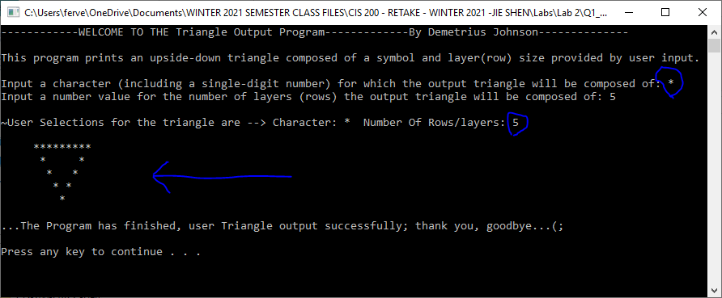

TEST 2:
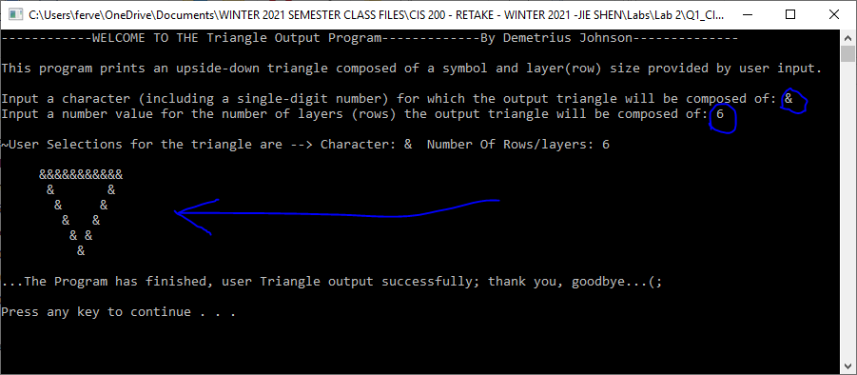

TEST 3:
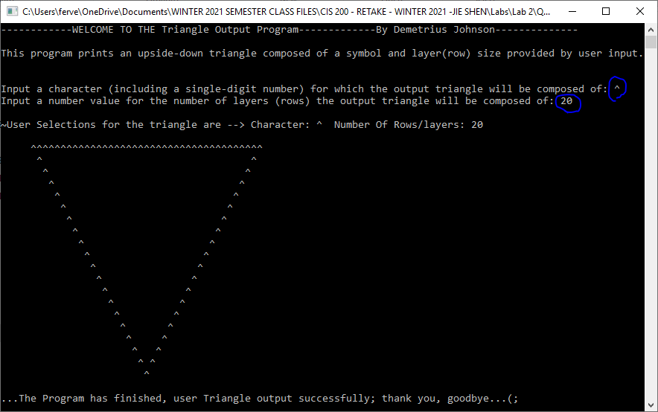

Question 2 (2.5 points)

Source code (USED C++ COMPILER)
// CIS 200 - LAB 2 - WINTER 2021 - DEMETRIUS JOHNSON.cpp : This file contains the 'main' function. Program execution begins and ends there.
//

/*
//Author: Demetrius E Johnson
//Date: 4 FEB 2021
//Last Modification Date: 2-5-2021
//Purpose: take a positive integer from users via cin and to print out the value of this number in its octal representation (8-based numbering system)

*/

/*

Question 2 (2.5 points)

//Write a program to take a positive integer from users via cin and to print out the value of this number in its octal representation (8-based numbering system).
//For instance, if you input 8, the output should be 10.

//You should test your program with the following inputs:
//12
//15

*/

#include <iostream>
#include <vector>
using namespace std;

int main()
{

int userInteger_base10 = 0; //use this to get user input and to convert their input from decimal to octal
int remainder = 0; //use this to store the remainder of any division results //set remainder to 1 in case user inputs '0', the for loop will still execute at least once
vector<int> placeValStorageVector_octal;

cout << "------------WELCOME TO THE Base-8 (Octal) Number Representation program-------------By Demetrius Johnson--------------\n\n";
cout << "This program prints a positive decimal (base 10) integer value\nfrom the user in its octal representation (8-based numbering system).\n";
cout << "For example: if you input '8', the output will be '10'\n\n";
cout << "Please input a base-10 (decimal system) integer (no fractions allowed) value to be converted to base-8 (octal numbering system).\n\nUser Input: ";
cin >> userInteger_base10;

cout << "\n\t" << userInteger_base10 << " [base-10] = ";

do{ //this loop will read in the place values of the octal value, but backwards (left to right, place values become stronger) //used do-while so it executes even if user inputs '0'

remainder = userInteger_base10 % 8; //get remainder, which will provide a place value digit of the octal number
placeValStorageVector_octal.push_back(remainder); //set element in the vector equal to the remainder (which is equal to the current place value digit of the octal number)
userInteger_base10 /= 8; //divide integer by 8 every instance to move to the next place value (power) that is necessary to convert the decimal number to octal number

} while (userInteger_base10 != 0);

for (int elementPos = (placeValStorageVector_octal.size() - 1); elementPos >= 0; elementPos--) { //this will output the octal value,
//starting from end of the vector which is where the larger place values are stored
//remember vector element position size is size - 1, since element 0 is included
cout << placeValStorageVector_octal.at(elementPos);
}

cout << " [base-8]" << endl;
cout << "\n...Program will now exit...Thank you(:...\n\n";
system("pause");
return 0;

}

Test data and expected results

Test Table:
Test # | Valid / Invalid Data | Description of test | Input Value | Expected Output | Actual Output | Test Pass / Fail
1 | valid | See if program correctly converts decimal number to an octal number | Decimal number: 12 | Octal number = 14 | See screenshot | pass
2 | valid | See if program correctly converts decimal number to an octal number | Decimal number: 15 | Octal number = 17 | See screenshot | pass
3 | valid | See if program correctly converts decimal number to an octal number | Decimal number: 64 | Octal number = 100 | See screenshot | pass
4 | valid | See if program correctly converts decimal number to an octal number | Decimal number: 129 | Octal number = 201 | See screenshot | pass

TEST 1:
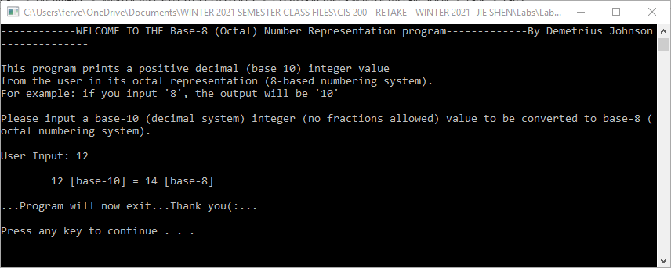

TEST 2:
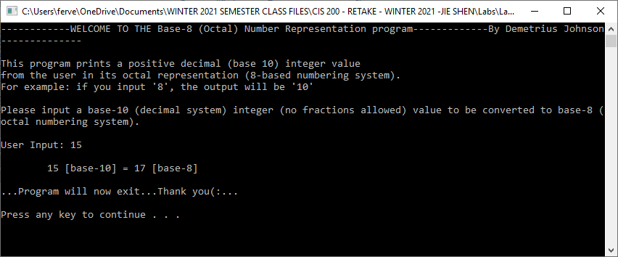

TEST 3:
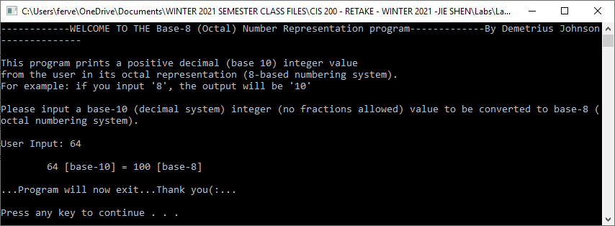

TEST 4:
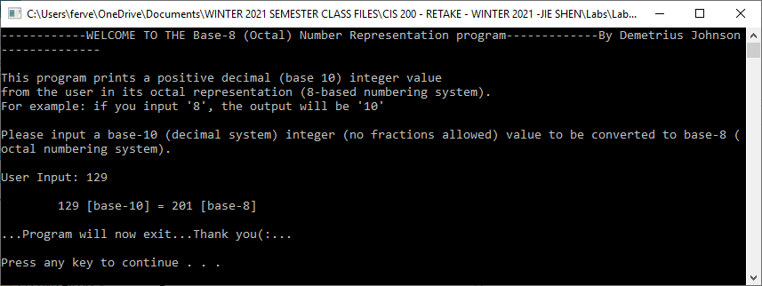

Question 3 (2.5 points)

Source code (USED C++ COMPILER)
// CIS 200 - LAB 2 - WINTER 2021 - DEMETRIUS JOHNSON.cpp : This file contains the 'main' function. Program execution begins and ends there.
//

/*
//Author: Demetrius E Johnson
//Date: 4 FEB 2021
//Last Modification Date:
//Purpose: use the concept of a macro --> preprocessor function/operation replacement directive

*/

/*

Question 3 (2.5 points)

Define a macro, getmin(a, b), by using #define …
getmin(a, b) returns a if a < b; otherwise return b.

Write a simple main( ) below:

int main( )
{

int a = 5, b = 10;

cout << getmin(a, b) << endl;
float x = 3.1, y = 6.4;
cout << getmin(x, y) << endl;

return 0;
}

*/

#include <iostream>
#define getmin(a, b) (a < b ? a : b)
using namespace std;

int main()
{

cout << "WELCOME-----This program shows the use of a macro function---By Demetrius Johnson-----\n\n";
cout << "The macro function is: #define getmin(a, b) (a < b ? a : b)\n\n";

int a = 5, b = 10;
cout << "int a = 5, b = 10\n\n";
cout << "Pre - processor directive will replace the getmin(a, b) with statement --> (5 < 10 ? 5 : 10)\n --> result: ";
cout << getmin(a, b) << endl << endl; //pre-processor directive will replace the getmin(a,b) with statement (5 < 10 ? 5 : 10)

float x = 3.1, y = 6.4;
cout << "\nfloat x = 3.1, y = 6.4;\n";
cout << "\nPre-processor directive will replace the getmin(x,y) with statement --> (3.1 < 6.4 ? 3.1 : 6.4)\n --> result: ";
cout << getmin(x, y) << endl; //pre-processor directive will replace the getmin(x,y) with statement (3.1 < 6.4 ? 3.1 : 6.4)

cout << "\n\n ~program has finished...thank you..goodbye(:...\n\n";

system("pause");

return 0;

}

Test data and expected results
Test Table:
Test # | Valid / Invalid Data | Description of test | Input Value | Expected Output | Actual Output | Test Pass / Fail
1 | valid | Output a test of the macro function | compare min val between 5 and 10; and between 3.1 and 6.4 | 5, and 3.1 | See screenshot | pass

TEST 1:
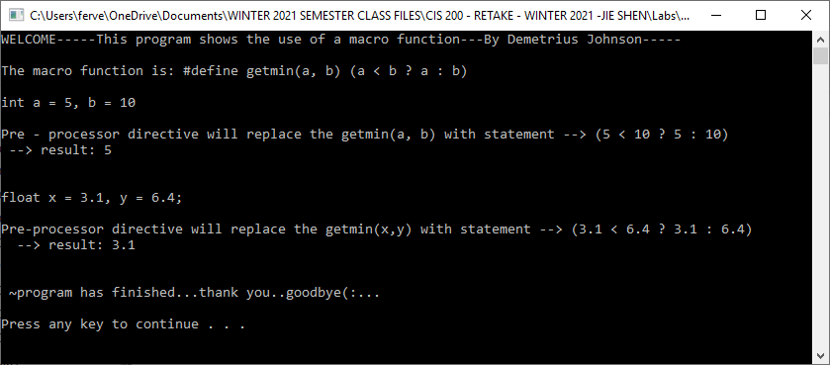

Question 4 (2.5 points)

Source code (USED C++ COMPILER)
// CIS 200 - LAB 2 - WINTER 2021 - DEMETRIUS JOHNSON.cpp : This file contains the 'main' function. Program execution begins and ends there.
//

/*
//Author: Demetrius E Johnson
//Date: 4 FEB 2021
//Last Modification Date:
//Purpose: Show the use of an inline c++ style function

NOTES:

A macro is a fragment of code which has been given a name. Whenever the name is used, it is replaced by the contents of the macro. (C style)

Inline function is a function that is expanded in-line when it is called.
When the inline function is called, the whole code of the inline function gets inserted
or substituted at the point of inline function call. (C++ style)

*Note, a macro is a the same as an inline function in that the contents are replaced by the compiler at compile time (pre-processor directive)

*/

/*

Question 4 (2.5 points)
Define an inline function, int getmin(int a, int b).
getmin(a, b) returns a if a < b; otherwise return b.

Write a simple main( ) below:

int main( )
{

int a = 5, b = 10;

cout << getmin(a, b) << endl;

return 0;
}
*/

#include <iostream>
using namespace std;

inline int getmin(int a, int b) { //inline function; no overhead from a function call; automatically the compiler replaces any code that calls this function with its line of code;
//no new memory needed to be allocated as like with a normal function call

return (a < b ? a : b);

}

int main()
{
cout << "-----WELCOME: This function shows the use of inline c++ style function -----By Demetrius Johnson\n\n";

cout << "Inline function:\n\n inline int getmin(int a, int b) { return (a < b ? a : b); }\n\n";
cout << "Function call:\n\n int a = 5, b = 10;\n\n cout << getmin(a, b) << endl;\n\nOutput results: ";

int a = 5, b = 10;
cout << getmin(a, b) << endl;

cout << "\n\n~Program has finished....thank you....\n\n";

system("pause");

return 0;
}

Test data and expected results

Test # | Valid / Invalid Data | Description of test | Input Value | Expected Output | Actual Output | Test Pass / Fail
1 | valid | Output a test of the Inline function | compare min val between 5 and 10 by pseudo-calling (really replacing with line of code) of the inline function | 5 | See screenshot | pass

TEST 1:
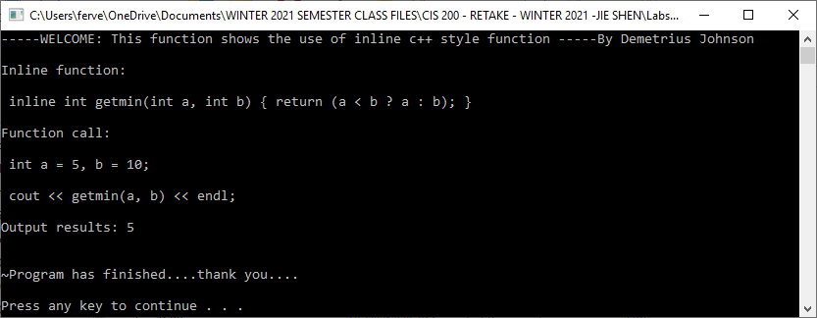

Submission

Provide the following:
- Cover page with lab number and title, your name, date

Source code (identify which compiler you used)

Test data and expected results

Running log/output (screen shots should be provided)
- Insert the source code and screenshots into the word document
- You should submit your work through Canvas site for cis 200 lab.
- The filename of the word document should follow the convention: FirstName_LastName_Cis200Lab2.doc.

